 | 16-18 Church Road,  Ashford,  TW15 2UT
RETAIL UNIT TO LET
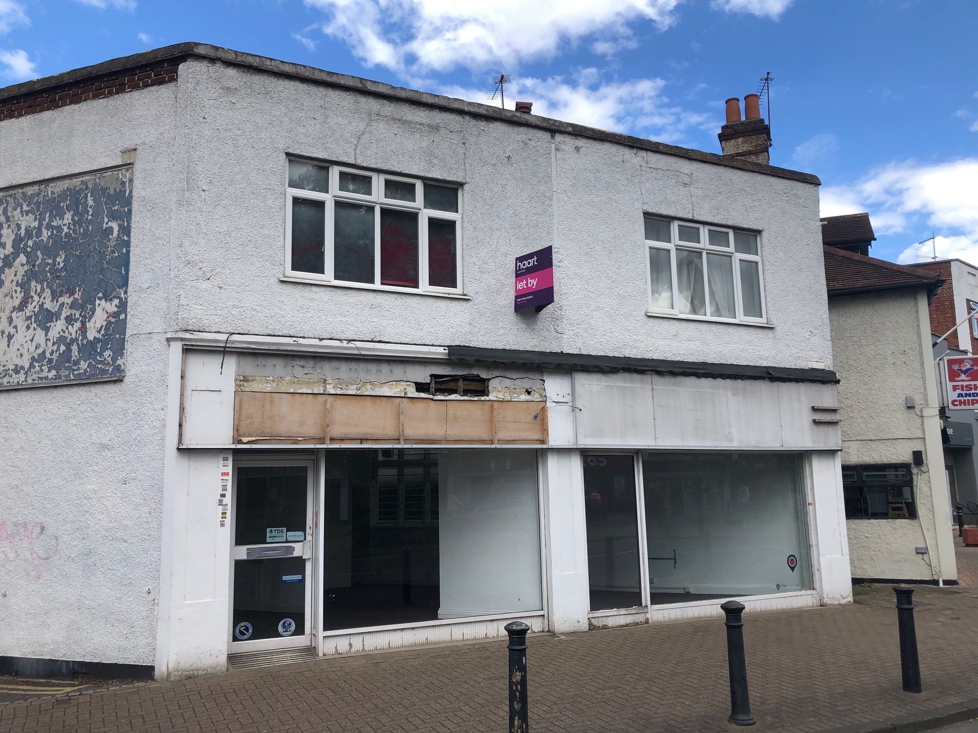 |  |  | LEGAL COSTS  Each party to bear their own legal costs.  USE  Commercial use E.  ENERGY PERFORMANCE CERTIFICATE (EPC)  C74.  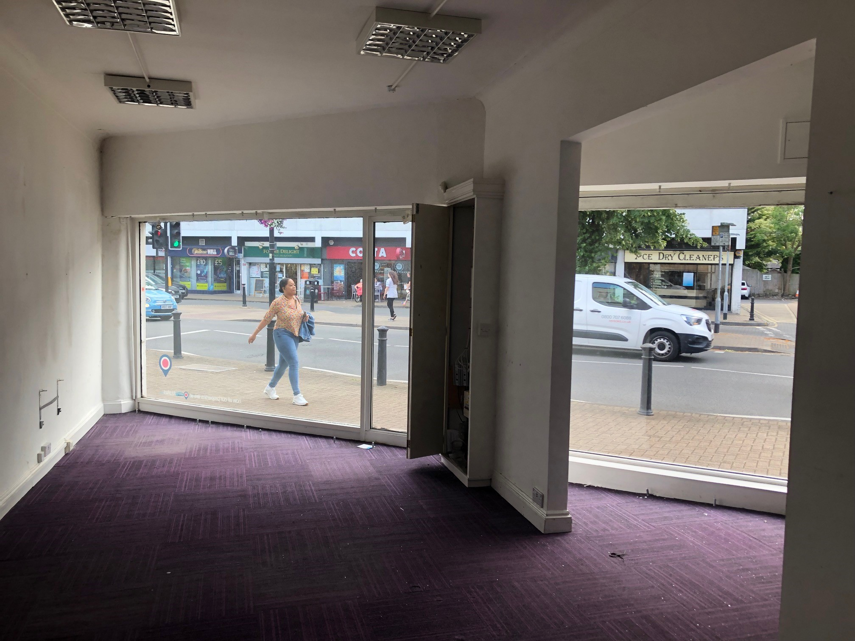  ANTI MONEY LAUNDERING  Michael Rogers LLP is regulated by the RICS and by HMRC in relation to its agency services and as a result is obliged to undertake anti money laundering checks on all parties proceeding with property transactions. We cannot proceed with any relevant property transactions without these checks having been satisfactorily completed and you will be asked to provide information to satisfy such checks.  VIEWING  For further information please contact sole agents:  Michael Rogers LLP  020 8332 7788  Niall Christian  niall.christian@michaelrogers.co.uk  July 2022
LOCATION
The property is located on Church Road a busy thoroughfare and is a short distance from Ashford mainline station. Church Road is close to the B378 which leads to the A308 and connects to the Sunbury junction of the M3. Numerous bus services serve the area. Local occupiers include, Sainsburys Local, Costa, Ashford Kitchens and Interiors, Corals and Tesco Express.

DESCRIPTION & FLOOR AREAS
The accommodation comprises a double ground floor retail unit.

The property benefits from solid ceiling, CAT II lights, kitchen, carpet, WC, electric heating and rear access.

Floor | SQ FT | SQM
Ground | 630 | 58.52
Total Approx. | 630 | 58.52

TERMS
The unit is held on an effective full repairing and insuring lease for a term of 10 years from 11th October 2013.

RENT
£18,000 per annum exclusive

BUSINESS RATES
Rateable Value £12,500 (Prospective tenants are advised to make their own enquiries with the Valuation Office Agency.) Small business rate relief maybe available.

Size 58.52 Sq. M (630 Sq Ft) approx.

The accuracy of any description, dimensions, references to condition, necessary permissions for use and occupation and other details contained herein is not guaranteed and is for general guidance only and prospective purchasers or tenants must not rely on them as statements of fact or representations and must satisfy themselves as to their accuracy. Neither Michael Rogers LLP nor any of their employees or representatives has any authority to make or give any representation or warranty or enter into any contract whatever in relation to the Property. Prices quoted in these particulars may be subject to VAT in addition. The reference to any mechanical or electrical equipment or other facilities at the Property shall not constitute a representation (unless otherwise stated) as to its state or condition or that it is capable of fulfilling its intended function. Prospective tenants/purchasers should satisfy themselves as to the fitness of such equipment for their requirements.

